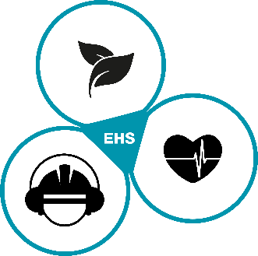
Code of conduct for visitors and external companies

Note on risk areas defined by the Robert-Koch-Institute
- Please check whether you have been in a currently designated risk area by the Robert-Koch-Institute in the 14 days prior to your visit. The classification of risk areas may vary from country to country. Therefore, please inform yourself in advance about the country-specific regulations applicable to the respective location visited.
- If you have been in a designated risk area for the last 14 days, you will only be allowed to enter the premises of the DRÄXLMAIER Group if you can prove that a PCR test carried out at a state-accredited laboratory at least five days after returning from a risk area is negative.

Prior to your arrival – Health self-check
- Before you can enter the premises of the DRÄXLMAIER Group, please carry out a health self-check by answering the following five self-check questions:
- I am under quarantine and/or belong to a risk group?
- My body temperature before the visit is measured at over 37,8 Grad Celsius / 98.6 degrees Fahrenheit?
- I have influenza, have to sneeze frequently and/or have a runny nose? (no known allergy is meant here)
- I cough regularly, the coughing stimulus comes unexpectedly and/or I've been having trouble breathing lately? I feel short of breath?
- I have signs of a cold with headache, joint and limb pain and/or I feel "flu-like"?
All five questions answered with NO: You are able to visit!
One question answered with YES and/or symptoms: Please stay at home!
- We reserve the right to carry out health checks on site.

Entering and leaving the factory premises
- Entering and leaving the factory premises during the pandemic will take more time than you are used to. Therefore, please remain calm and always keep a minimum distance of 1.5 meters from other persons. This also applies if you have to wait in front of entrances and exits.
- Follow the instructions of the plant security as well as the signs and floor markings on the company premises.
- A mouth and nose mask must always be carried. This must be shown to the plant security without being asked before entering the company premises.
- Please also inform yourself in advance about the current 7-day incidence value of the respective district of the visited location. If this exceeds 35 new infections per 100,000 inhabitants within seven days, there is a general mask obligation at this location.

Social Distancing
- Always keep a minimum distance of 1.5 meters from other people. If this is not possible, please use a mouth and nose mask.
- Observe the maximum occupancy rate, which applies in meeting rooms, among other places.
- Avoid shaking hands.

Breaks
- Keep a minimum distance of 1.5 meters even in the smoking areas.
- The use of the canteens is currently prohibited for external persons.

Stop the spread of the virus
- Wash your hands as often as possible with soap and water for at least 20 seconds. (Hand washing rules are posted in every washroom).
- Cough and sneeze properly - cover your nose and mouth with a handkerchief, napkin or elbow crease.
- If you feel ill, please contact your contact person immediately by telephone and leave the company premises directly.

